Design Document

Meal Planning Calendar

Document Version: 1.0

**Team Members:** Jonah Backfish, Michael Anderson-Liggett

# **Introduction**

State licensed childcare facilities in Indiana have the option to enroll in a food reimbursement program known as the Child and Adult Care Food Program (CACFP). A central goal of this program is to offer meal planning guidance to meet the nutritional needs of children that are enrolled in childcare programs. One stipulation of this program requires participating facilities to pre-plan meals in accordance with the CACFP’s meal pattern requirements. These meal plans must be created in advance and made available to parents.

This document outlines the design of a web application that streamlines the meal planning process. This program will be used to create meal plans that meet CACFP standards, generate a document containing a meal plan calendar, and print the document for distribution to parents. It will run on the client/server model as an application embedded into an existing website for a childcare facility. The system will primarily be developed with PHP, HTML, CSS, and Javascript, with MySQL employed for data storage.

# **Architecture**

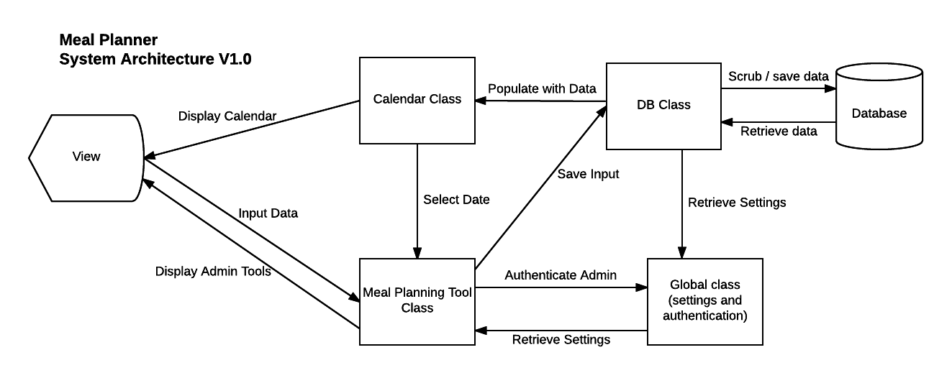

# 

# **Use Cases**

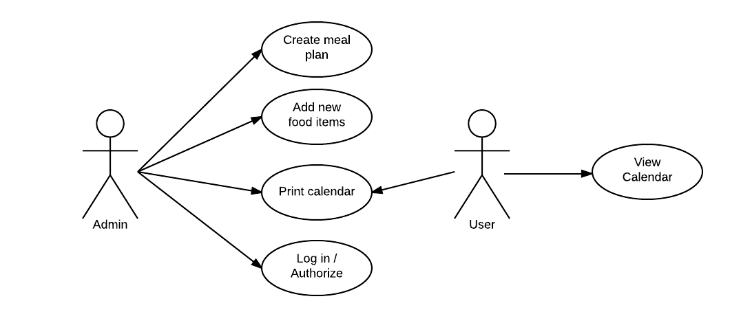

# **UML**

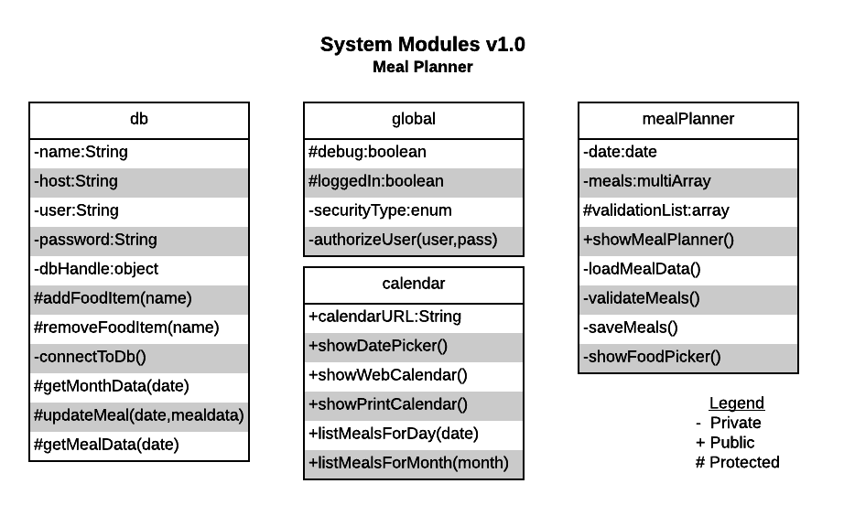

# **Test Cases**

|  |  |  |
| --- | --- | --- |
| **Requirement** | **Test Case** | **Expected Result** |
| **1.** **If authorization is required, the system should request authentication before access to administration tools is granted** | 1.1. Attempt to log into an administrator account with an existing username and password  1.2. Attempt to log in with a valid username and invalid password  1.3. Attempt to log in with an invalid username and a valid password  1.4. Attempt to log in with an invalid username and password | 1.1. User is authenticated and logged in  1.2. User is not authenticated and login fails with a notification  1.3. User is not authenticated and login fails with a notification  1.4. User is not authenticated and login fails with a notification |
| **2.** **The system should save meal plans designed for specific dates** | 2.1. Use the meal planning tool to modify the meal plan for various dates | 2.1. The data should be stored as relevant database entries, with no change to unrelated data |
| **3.** **The system should save new foods added by the administrator** | 3.1. Use the meal planning tool to attempt to insert new foods into the database  3.2. Use the meal planning tool to attempt an injection attack via the food input form | 3.1. The data should be stored as relevant database entries, with no change to unrelated data  3.2. The system should escape and sanitize the input, storing it safely in the database with no breach of security, disruption of normal web page display, or alteration in unrelated data |
| **4.** **The system should display a calendar formatted for printing on a single page** | 4.1. Use the system to generate a calendar, then attempt to print it | 4.1. The result should be a properly formatted calendar that fits on a single page and displays the meal plan for the month |
| **5.** **The system should easily integrate into an existing website for a childcare facility** | 5.1. Use the calendar class to create a new meal plan for the facility and display it on the public facing pages, and use the meal planning class to embed the administration tools into the website’s administration panel. | 5.1. The system integrates seamlessly into the existing website with little effort, and continues to function normally and pass all test cases. |

# **Summary**

In summary, the system is designed to create and distribute CACFP approved meal plans for a childcare facility. The system’s design will utilize a simple object oriented approach in which various objects will handle specific functionality of the application. Instances of these objects will be used to embed controls and display output on an existing webpage, and will be used to retrieve and store data in the database. Various test cases have been established to ensure that the final application functions as expected.